28.76: a) 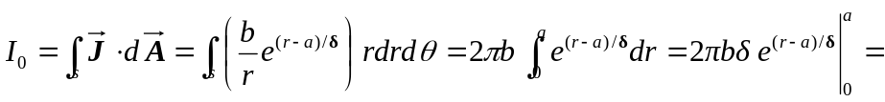
b) For 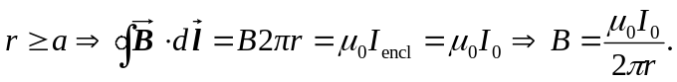
c) 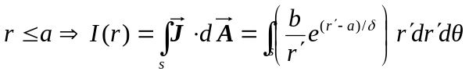
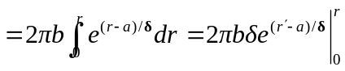
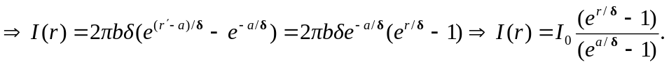
d) For
e) At 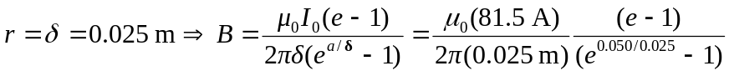
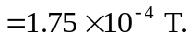
At 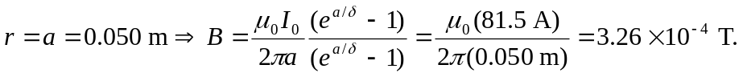
At 